Forensics Challenge 1
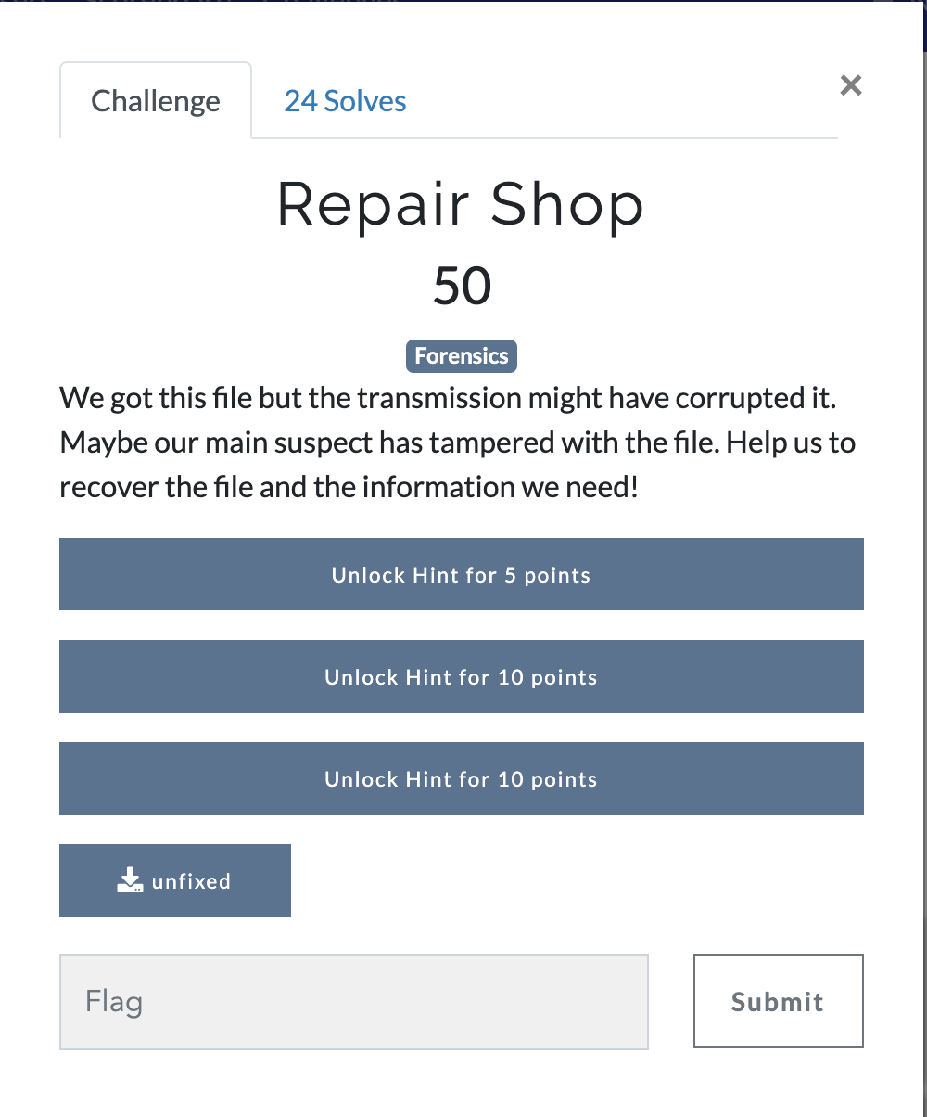
Answer: We are given a file named unfixed, looks be just raw data
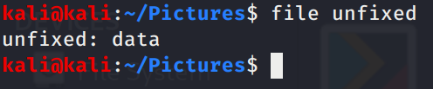
Let’s use binwalk to see if there is anything inside of it. Looks to be a txt file called theflag.txt lets extract everything
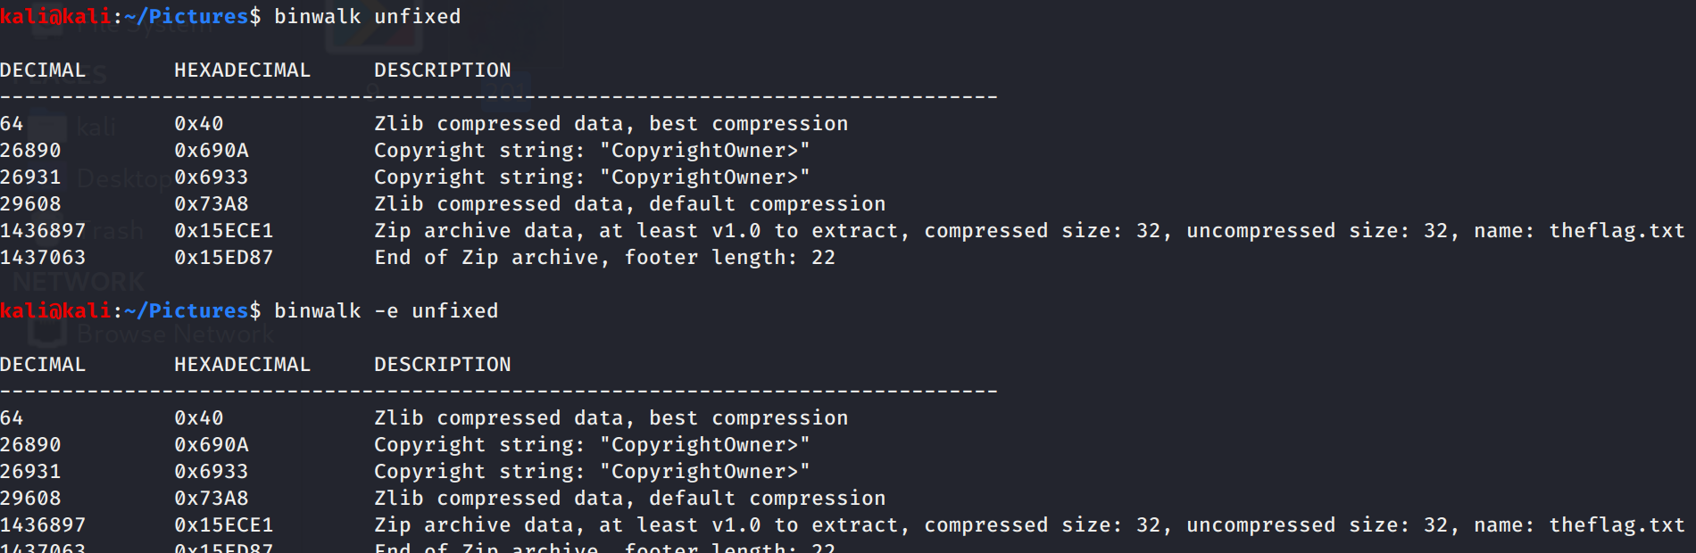
Cat out theflag.txt to find a base64 string and decode the string to get a false flag.
False Flag: hilltopMSG{keep_looking}
Ok Hilltop lets keep looking, what other files did we get.
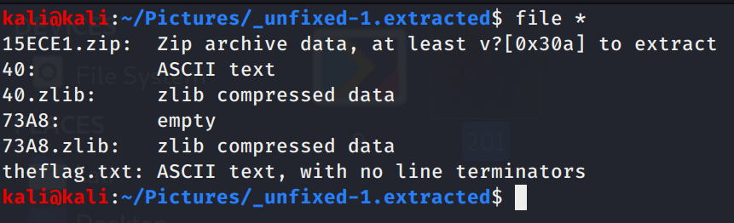
Another ascii file, 40. Cat the file looks to be a hex dump, let’s decode and store the results.
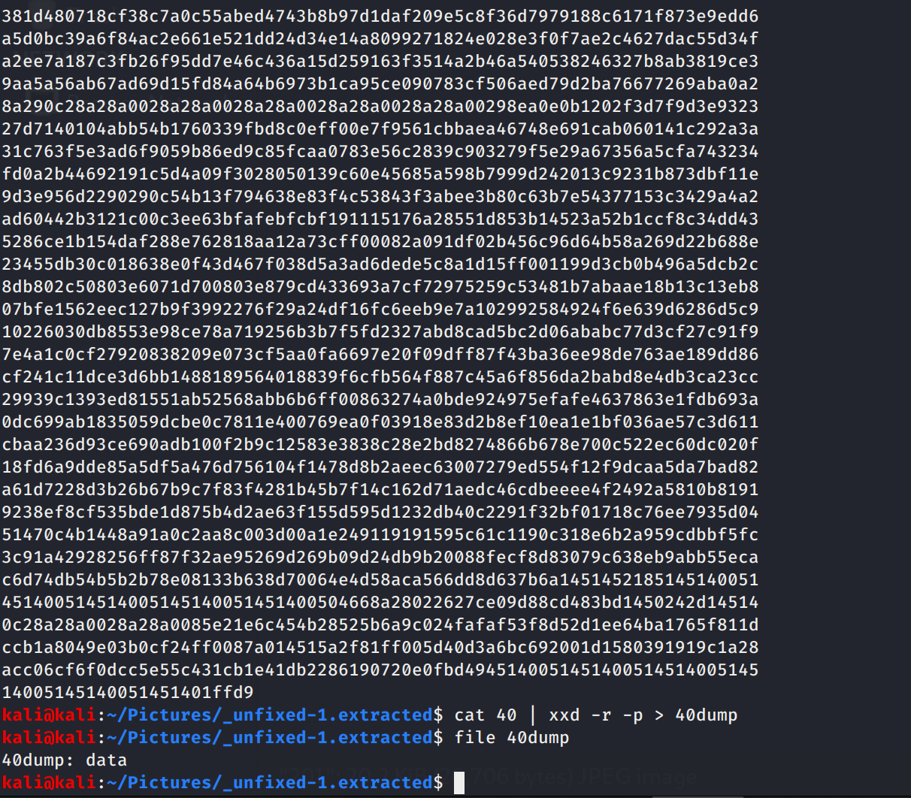
Interesting another data file. If we cat the 40dump we get nothing really useful so let try binwalk again.
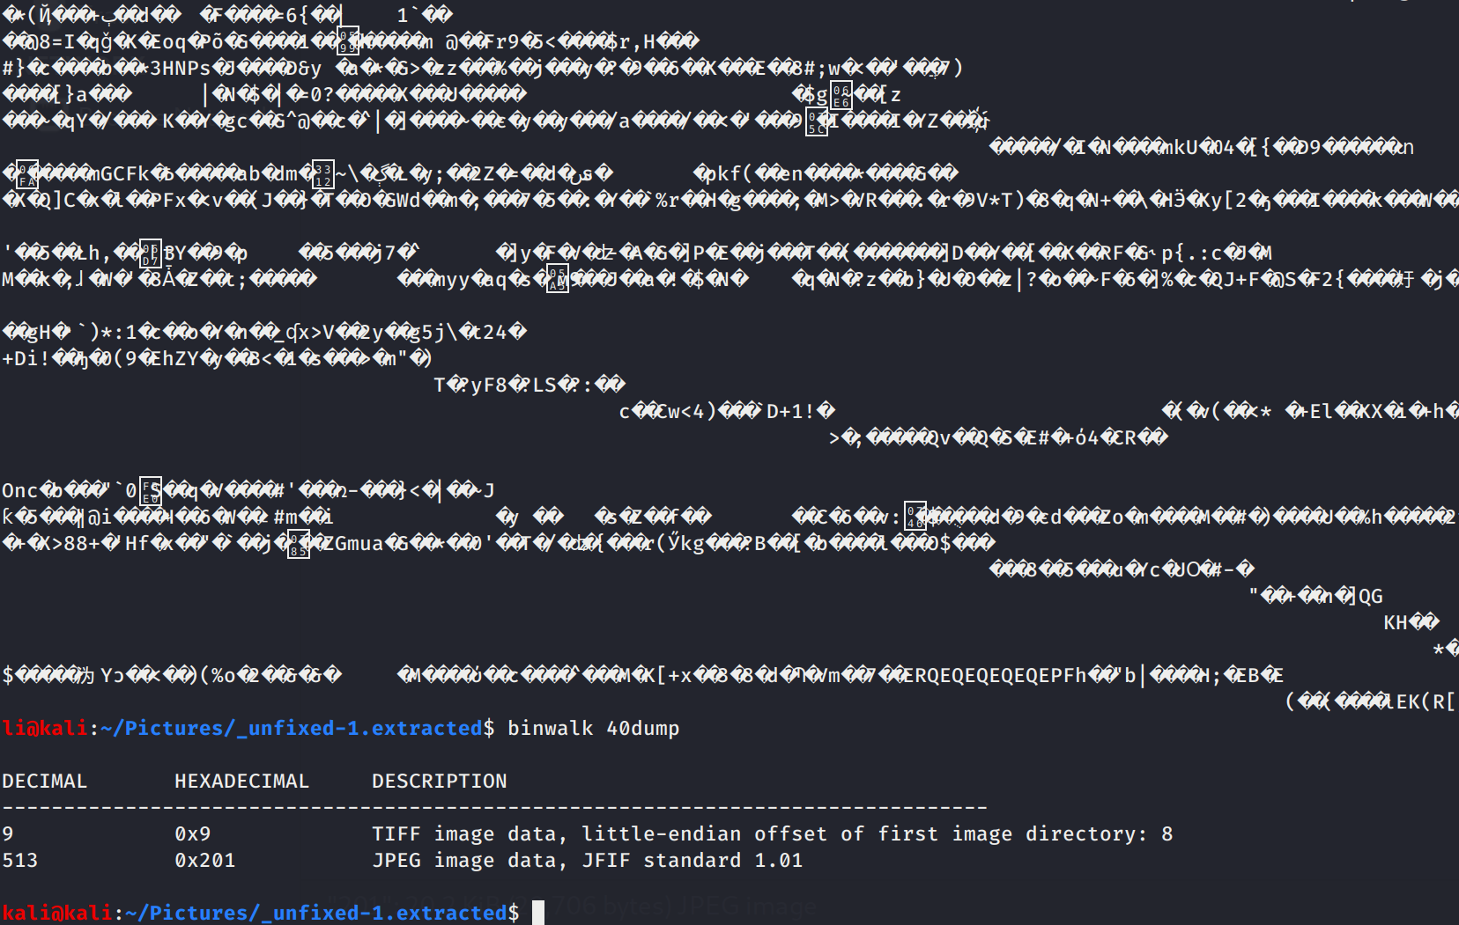
A JPEG file, lets extract it and open it.
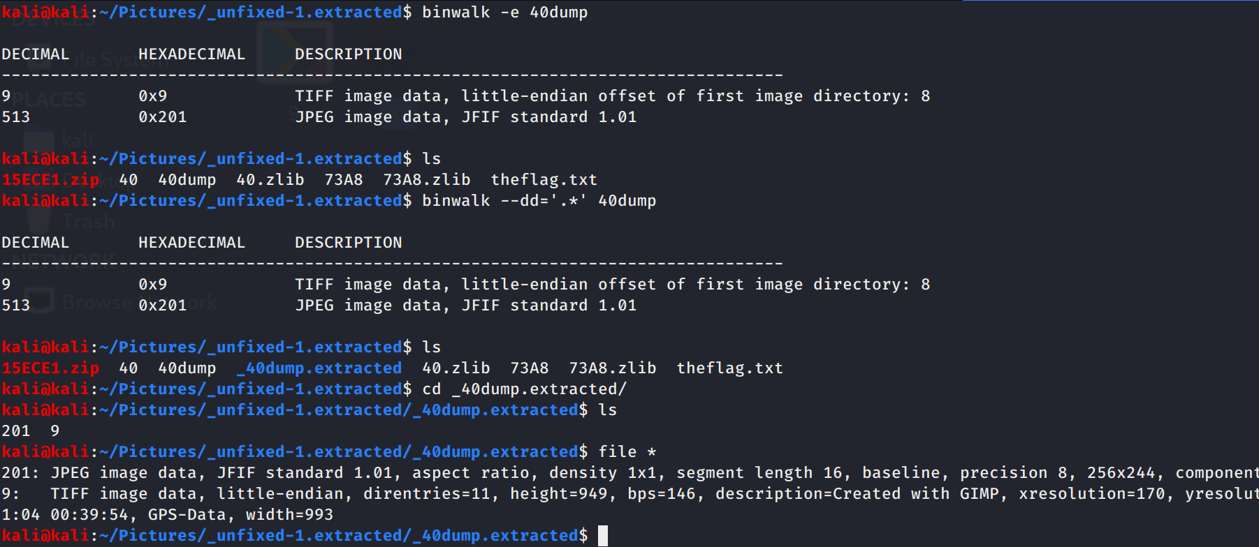
So using the normal -e option with binwalk failed, this can happen, so let’s use dd instead. Now we have the JPEG lets open it up.

Looks like we have our flag
FLAG: hilltopCTF{PNG_M4gic_Numb3R5}

